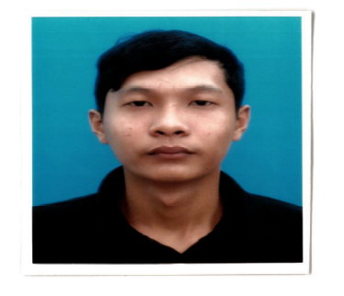

RESUME

MUHAMMAD FADHIL BIN BAHARIN

No. 90 Jalan 5/2B,
Taman Desa Bakti,
68100 Batu Caves,
Kuala Lumpur.

No. I/C : 931017-14-5149
Contact No. : 017-2407990
E-mail : fadhilm347@gmail.com

CAREER OBJECTIVES

I am a dedicated and enthusiastic with strong leadership and communication skills and to use my skills in the best possible way for achieving the company’s goals.
PERSONAL DETAILS

Date of Birth : 17 October 1993 Place of Birth : Kuala Lumpur

Marital Status : Single Citizen : Malaysia

WORKING EXPERIENCE

- Kitchen : CAFÉ HSBC (August 2010 – October 2010)
- Assistance cook (part time)

- Kitchen : GLORIA JEANS (Mei i 2014)
- Cooking
- Western Food

EDUCATION BACKGROUND

2011-2014 : Universiti Institut Teknologi Mara Melaka Alor Gajah
Diploma in Banking
CGPA : 2.62

2005– 2010 : Sekolah Menengah Kebangsaan Raja Ali
SPM: 2A ,2B ,2C

KOKURIKULUM

Sports : Badminton
Position hold : Vice President
Level of participation : Zone level Sentul

Uniform : Kadet Bersatu Malaysia (PKBM)
Position Hold : Committee
Level of participation : 2nd Runner up – State level

Club / Association : Persatuan Kadet Bersatu (PKBM
Position Hold : Committee
Level of participation : School Level

Club / Association : Kelab Majlis Agama Islam
Position Hold : AJK
Level of participation : School Level

SKILLS

- Excellent in Microsoft Word, PowerPoint dan Excel.
- Communication Skills in Bahasa Malaysia and English.
EXPECTED SALARY

- RM 1100 - 1500

REFERENCES

Puan Shahiszan Binti Ismail
Fakuliti Diploma In Banking
Universiti Institut Teknologi Mara
Alor Gajah
Melaka

Tel : 013 229 2087

